Low-Level Design
# Source: AI Source: Provided by: [Data Path: Persons Table -> ID Column: 1, Name_En Column: Motasem Essam] -> From: [ChatGPT] on [1/23/2026]
Low-Level Design (LLD) is the detailed design phase that focuses on how each module or component is implemented. It translates the High-Level Design (HLD) into concrete classes, methods, and data structures.
👉 LLD is like the detailed construction plan of a building—walls, wiring, plumbing, and materials.

🔑 Key Points of LLD
# Source: AI Source: Provided by: [Data Path: Persons Table -> ID Column: 1, Name_En Column: Motasem Essam] -> From: [ChatGPT] on [1/23/2026]
- Provides class-level and method-level design
- Defines algorithms, data structures, and logic
- Shows relationships between classes
- Focuses on how modules work internally
- Used as a blueprint for coding

🧱 What LLD Includes
# Source: AI Source: Provided by: [Data Path: Persons Table -> ID Column: 1, Name_En Column: Motasem Essam] -> From: [ChatGPT] on [1/23/2026]
- Class Diagrams
  - Classes, attributes, methods, visibility
- Sequence Diagrams / Flowcharts
  - How methods are called
  - How data flows step by step
- Data Structures
  - Arrays, lists, maps, trees, etc.
- Algorithm Design
  - Logic for calculations, processing, sorting, etc.
- Error Handling & Validation
  - Exceptions, logging, input checks

❌ Bad Example (Skipping LLD)
# Source: AI Source: Provided by: [Data Path: Persons Table -> ID Column: 1, Name_En Column: Motasem Essam] -> From: [ChatGPT] on [1/23/2026]
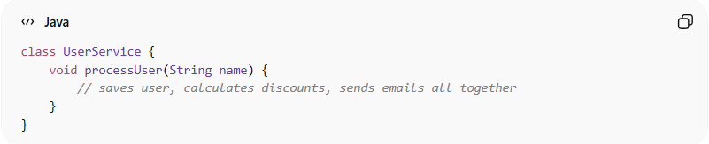
class UserService {
void processUser(String name) {
// saves user, calculates discounts, sends emails all together
}
}
👉 Problems:
- Single method does too much
- Hard to test or maintain
- No clear method-level design

✅ Good Example (LLD Approach)
# Source: AI Source: Provided by: [Data Path: Persons Table -> ID Column: 1, Name_En Column: Motasem Essam] -> From: [ChatGPT] on [1/23/2026]
Class Structure
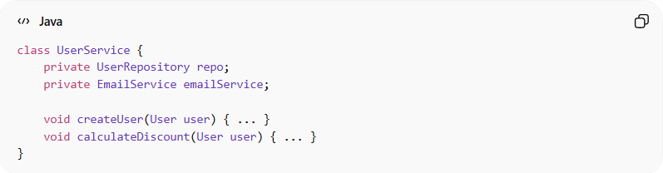
class UserService {
private UserRepository repo;
private EmailService emailService;

void createUser(User user) { ... }
void calculateDiscount(User user) { ... }
}
Method-Level Logic
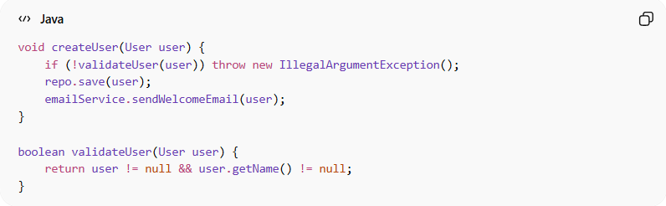
void createUser(User user) {
if (!validateUser(user)) throw new IllegalArgumentException();
repo.save(user);
emailService.sendWelcomeEmail(user);
}

boolean validateUser(User user) {
return user != null && user.getName() != null;
}

💡 Benefits of LLD
# Source: AI Source: Provided by: [Data Path: Persons Table -> ID Column: 1, Name_En Column: Motasem Essam] -> From: [ChatGPT] on [1/23/2026]
- Clear blueprint for developers to implement
- Easier testing and debugging
- Reduces chances of errors during coding
- Improves maintainability and extensibility

🧭 Key Idea
# Source: AI Source: Provided by: [Data Path: Persons Table -> ID Column: 1, Name_En Column: Motasem Essam] -> From: [ChatGPT] on [1/23/2026]
HLD answers “what” the system will do, while LLD answers “how” each part will work in detail.

